Module 3

Assignment 3.2
Course: CSD420-340A Advanced Java for Programmers
Prepared By: Mirach Erkol
Date of Report: 4/11/2026

https://github.com/Mikey5007/csd-420.git

3.2 Assignment: Running in PowerShell
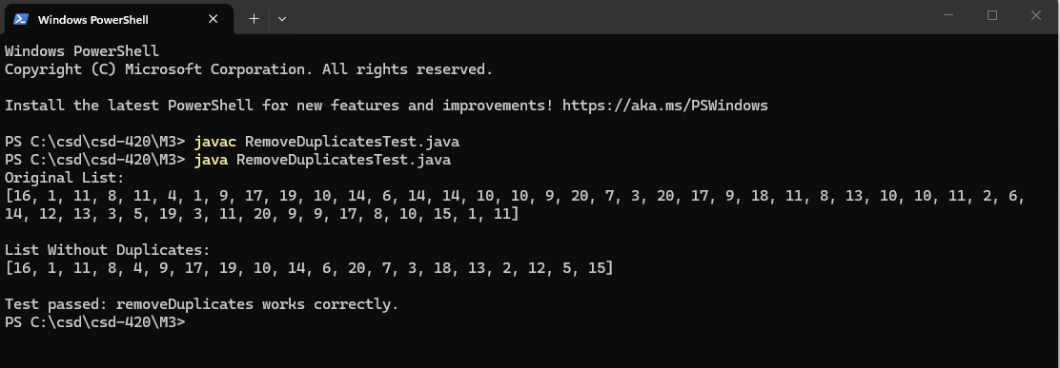

3.2 Assignment: Running in NetBeans
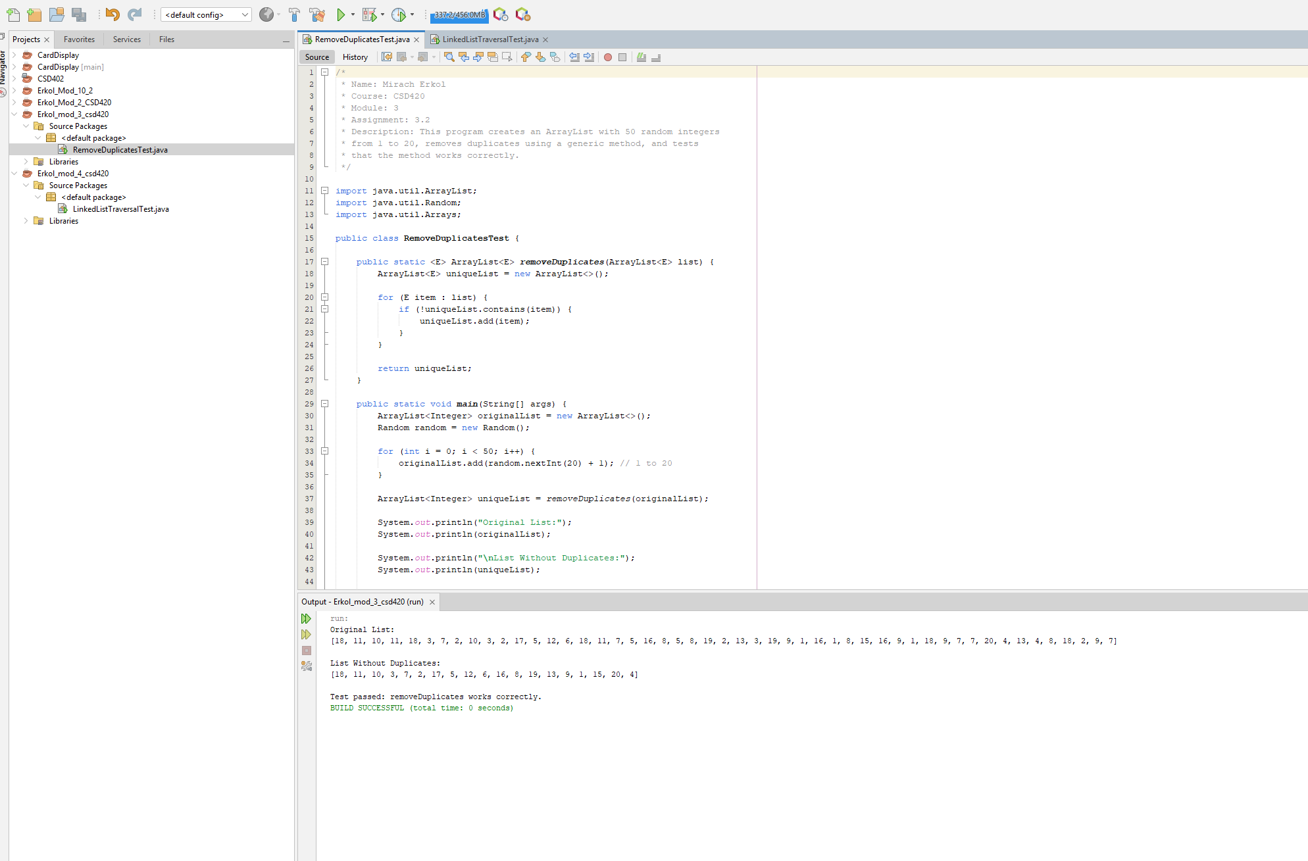

References:

https://github.com/Mikey5007/csd-420.git

